Jerzy Uścinowicz, Prof. D.Sc. Ph.D., Eng, Arch
Curriculum vitae
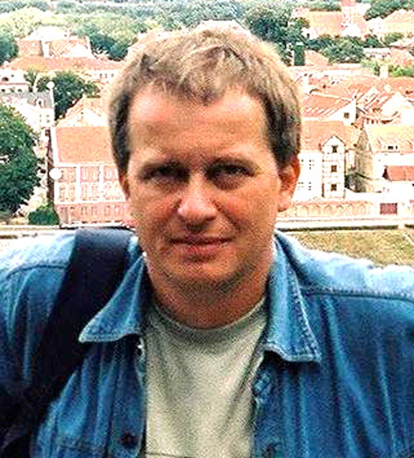

Jerzy Uścinowicz was born in 1962 in Białystok. He is a professor of the Białystok University of Technology and the head of Division of Architecture of Local Cultures in the Faculty of Architecture of the Białystok University of Technology.
In 2002-2005 he was a vice dean of research in the Faculty of Architecture. He lives and works in Białystok.
He completed architectural studies with distinction in 1986. In 1984/1985 and 1985/1986 he was awarded the prize of the Ministry of Science and Tertiary Education.
He obtained a doctor’s degree with distinction for the theses: ’Tradition as a Criterion in the Orthodox Church Architecture. Transposition of tradition as demonstrated in Contemporary Orthodox Church Architecture in Podlasie’ in 1997 at the Faculty of Architecture of the Warsaw University of Technology for which he was awarded the first individual prize of the Ministry of National Education as well as the Ministry of Administration and the President of the Housing and Cities Development Prize.
He is an author of over 70 scientific publications (national and international): one monograph, 3 books (as a co-author) and 70 articles, mainly about a sacral architecture of the cultures dwelling on the border. In 1997 he published the scientific monograph: ’Symbol, Archetype, Structure – Hermeneutics of Tradition in the Architecture of the Orthodox Church’. It is a verbal and iconographic synthesis of many years of studies on the tradition in the sacral architecture.
He is an author or a co-author of over 60 architecture designs, mainly of public utilities architecture. He designed 24 sacral buildings and complexes 12 temples of which have already been built and the remaining ones are in the process of being built. They are mainly orthodox and roman catholic churches, monasteries, parish ensembles, memorial complexes and chapels in: Białystok (4), Bielsk Podlaski (2), Grodno (Byelorussia), Bobrowniki, Plutycze, Walbrzych, Buczyna, Ząbkowice Slaskie, Sokolowsko, Kuznica Bialostocka, Wasilkow, Odrynki, Polock (Byelorussia), Sokolowsko, Minsk-Kamienna Gorka (Byelorussia), Dojlidy, Zabłudów, Grabarka (2), Supraśl (2) and an ecumenical church at the University of Technology in Białystok.
He has participated in over 30 architectural national and international competitions and was awarded 12 prizes and distinctions. He was a laureate of the international competition for the Temple-Memorial in Moscow, competition for the monastery on the Holy Mountain in Grabarka (1st prize), International Biennale of Architecture in Krakow, competition for the International Centrum of Esperanto in Białystok, competition for the “Kamienica Ełcka” building (1st prize), competition for the theatre of the Centre of Theatre Practices “Gardzienice” (1st prize), competition for the centre of the old town of Bialystok and competition for the Main Library of the University in Bialystok and many others.
In 1986-2011 he directed or coordinated 18 research projects 11 of which were international. In 1998-2011 he presented of over 70 papers at international conferences on sacral architecture in Lvov, Lyon, Paris, Moscow, Minsk, Sevastopol, Kiev, Vilnius, Riga, Chernigov, Istanbul, Torino, Debrecen, .
He is an author of 30 individual exhibitions of sacral architecture among others in Vilnius, Moscow, Kiev, Lvov, Minsk, Brest, Białystok, Paris, Warsaw, Kielce, Bratislava, Krynica, Riga, Chernigov, Poltava, Grodno, Polotsk, Tbilisi-Gori-Nikozi, Podgorica-Niksic.
He was a promoter of 70 master dissertations in the field of architecture which were awarded 47th prizes, distinctions and nominations in regional and national competitions including 2 awards and 1 distinction of the Ministry).
He was an organizer and co-organizer of the following international conferences: ‘Architecture of Local Cultures Borderland’ in 2003 and 2009), conferences ‘Sacred and Monumental Buildings’ (6 editions) and ’Congress of Polish Architect in Białystok’ in 2005.
He has been a member of the Committee of Architecture and Urban Planning of the Polish Academy of Sciences since 2004, is a member of the working program ‘Spiritual Places’ of the International Union of Architects, a member of the Presidium of the Association of Polish Architects SARP, the chairman of the Regional Council of the Conservation in Podlasie region in Poland and a member of the Care of Monuments of the Sacred Art Committee.
He was awarded the Prince Ostrogsky Prize in 2000, St. Marie Magdalene Prize in 2010 and the prestigious St. Brother Albert Price in 2005 for his outstanding contributions in science and sacred art.
He is a professor of the International Academy of Architecture.

